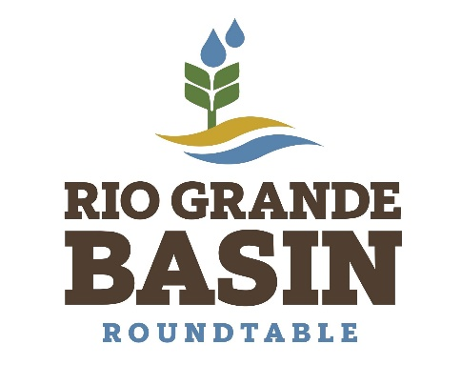

Inter Basin Compact Committee Basin Roundtables
Rio Grande Basin Roundtable

Tuesday, May 11, 2021 at 2:00 pm
Zoom Meeting Online

Meeting Minutes

Call to Order
Meeting called to order at 2:00 pm by Nathan Coombs, chairman. Those in attendance included Karla Shriver, Charlie Spielman, Ann Bunting, Steven Romero, Bethany Howell, Mike Gibson, Nathan Coombs, Rio de la Vista, Karla Shriver, Amy Ostdiek, Cary Aloia, Cath Morin, Christi Bode, Chuck Finnegan, Cindy Medina, Daniel Boyes, Darin Schepp, Daryl Kohut, Emily Chavez, Emily Zmak, Emma Reesor, Erin Minks, Glen Miller, Hallie Flynn, Heather Dutton, J Slivka, Jenny Nehring, Judy Lopez, Kat Weismiller, Kevin Terry, Mike Roque, Robert Hurd, Robert Sakata, Ronda Lobato, Russ Sands, Ryan Unterreiner, Taylor Adams, William Myers, Allen Law, Nikita Christensen, Jim Ehrlich. Peter Clark was excused.
Agenda
Chairman asked for approval of the agenda as presented by general consensus. No changes were made so agenda was approved.

Minutes
Minutes for the April 13, 2021 meeting were presented. They were approved by general consensus with amendments to the attendance as follows. Ronda Lobato, Dale Kohut, and Rio de la Vista were in attendance.

Public Comment
Judy Lopez reminded the membership that they need to put in their letter of interest for at large members and for appointees to notify their appointments. Another email will be sent to the entire Roundtable mailing list as the time frame for notifying the executive committee is coming up. Cindy Medina noted that the Colorado Water Trust gave Kevin Terry and Nathan Coombs an award. Congratulations from those in attendance. Rio de la Vista gave an update about attorney general Phil Weiser potentially coming to the Valley during next month’s meeting. Tentatively planned for the Reeds, the restaurant at the golf course, for outdoor attendance.

PEPO Update
Bethany discussed CWCB Education Workshop and showed the finished Agriculture and Water video by Christi Bode of Moxiecran Media, LLC in partnership with the Colorado Potato Administrative Committee.

Demand Management Report
Amy Ostdiek and Emily Zmak from the Colorado Water Conservation Board updated the Roundtable on the work with the Colorado River’s Demand Management plan. Colorado is involved in a feasibility investigation that must be agreed upon by upper basin states, who are also creating their own feasibility investigations. The presentation walked through the sideboards of the conversation and the CWCB’s involvement with facilitating the conversation around demand management. Information was solicited from stakeholders, work groups, board members, and others to create a foundation for framing the plan. The end result is to determine whether a demand management plan on the Colorado River is feasible. Questions regarding time frame highlighted that the work will be ongoing and will probably continue into the next few years. Next steps include surveys, workshops, and listening sessions in June. Information can be found at www.engagecwcb.org.

Basin Plan Update
Daniel Boyes discussed that the BIP is being drafted into documents compiled from the data gleaned from the subcommittee meetings. Volume 1 and Volume 2 are being created from new and 2015 BIP information. CWCB staff will do an initial review in June, edits from the Roundtable will be solicited in August.

Economic Value of Cranes
Jenny Nehring from Wetland Dynamics, Friends of the SLV National Wildlife Refuges, and Monte Vista Crane Festival gave a presentation regarding a project determining the economic value of cranes to the San Luis Valley. The project was carried out by the above partners as well as Colorado Open Lands. A survey of visitors to the 2020 festival as well as pneumatic vehicle counters were utilized for determining overall numbers which included time periods around the festival for up to 60 days. Revenues from non-local and local visitors was found to be significant in the total amount of more than $3m. Overall conclusions support that water resources protection is vital to keeping cranes healthy and vibrant and of continuing economic importance to the Valley.

Subdistrict Report
No staff were in attendance to give an update on the subdistricts.

Colorado Division of Water Resources Report
Darin Schepp from Division 3 gave the report on current streamflow and curtailment.
Snowpack peaked on March 30th, we are down to 44% of normal currently. 79% of average precipitation, although April was 33% of normal and has diminished precipitation. Abnormally dry to moderate drought. Rio Grande stream flows estimated at 278,000 AF, obligation at 90,000 AF. Currently at 7% curtailment. Conejos River flows estimated 162,000 AF, obligation 54,000 AF. Currently at 10% curtailment. Costilla Compact meeting will take place on May 18th. John Skinner, well commissioner, will retire at the end of the month. Article 7 restrictions apply for the Rio Grande Compact, meaning post-Compact reservoirs are not permitted to store water. Abandonment objections are due by June 30th. Question regarding the Saguache Creek subdistrict ARP which Darin responded had not been approved, but that there is optimism that something will be put into place in the next few weeks. Some further discussion regarding melt within unshaded forest areas with large stands of dead trees.

Colorado Water Conservation Board Report
Russ Sands from CWCB talked about upcoming events such as the Water Equity Task Force Meeting on May 18th, Riverside Chat II, and other information found at www.engagecwcb.org.

Other Business
Next Roundtable Meeting will take place on June 8, 2021 at 2:00pm

Meeting adjourned at 3:39 pm.

